CHInhoyi University of Technology Chinhoyi University of Technology

Research, Innovation and Business Incubation

Innovation Hub

Phone+263 6721 22203-5 Ext 5110

**_____________________________________________________________________________________**

17 February 2023.

To Whom it May Concern:

It is my pleasure to recommend Nyakudanga Raymond Ronald for admission to Master’s program for Scholarship. I came to know Nyakudanga when I was his lecturer for instrumentation and embedded control, control engineering and autonomous robotics at Chinhoyi University of Technology. The courses were part of a bachelor of Engineering degree in Mechatronics. Nyakudanga was highly proficient in applying the course material in analyzing the problem situations Nyakudanga also distinguished himself by submitting an exceptionally well researched and interesting project on a smart public transport management system.

I would rank him in the top 5% of students that I have taught in the past ten years in respect of his technical ability and research skills. Overall, Nyakudanga is highly intelligent and has good analytical skills. His project on smart public transport management system demonstrated his ability to develop advanced national problem-solving solutions.

Nyakudanga has excellent communication skills. His written work is both clear and concise, as well as interesting to read. He demonstrated his oral articulateness in the discussion sections that were an integral part of the project dissertation scoring. He always explained his views very concisely and gave supporting arguments that were both clear and persuasive.

At a personal level, Nyakudanga is a well-disciplined, industrious student with a pleasant personality. Not only was he interested in and motivated to learn the material, but he also put great work into assimilating it to his own experience and developing his own ideas about each topic that we discussed. If I can be of any further assistance, or provide you with any further information, please do not hesitate to contact me.

Yours sincerely,

Sincerely,

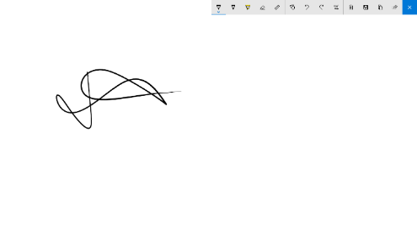

Eng. Powell Mlambo

Technical Manager

Research Innovation & Business Incubation

Chinhoyi University of Technology

+263772 520 728

pmlambo@cut.ac.zw / pmlambo@gmail.com